Section 3-1: Parallel Lines and Transversals

SOL: None

Objectives:
Identify the relationships between two lines or two planes
Name angles formed by a pair of lines and a transversal

Vocabulary:
Parallel Symbol (║)
Parallel Lines – coplanar lines that do not intersect
Parallel Planes – planes that do not intersect
Skew lines – lines that do not intersect and are not coplanar
Transversal – a line that intersects two or more coplanar lines at different points

Key Concepts:

Example 1: A group of nature trails is shown. Identify the sets of lines to which each given line is a transversal.
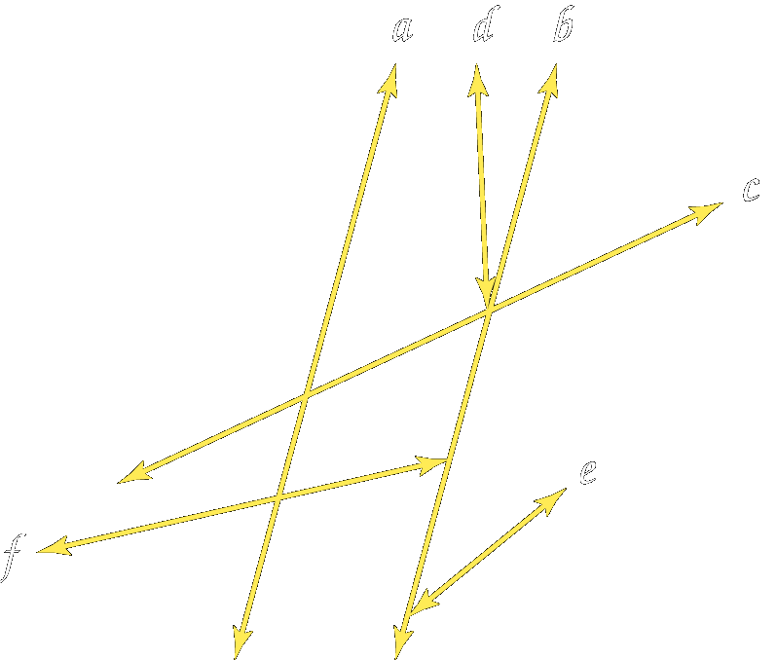
a. line a

b. line b

c. line c

d. line d

Example 2: Given the following figure, identify each set of angles as alternate interior, alternate exterior, corresponding, or consecutive interior angles.
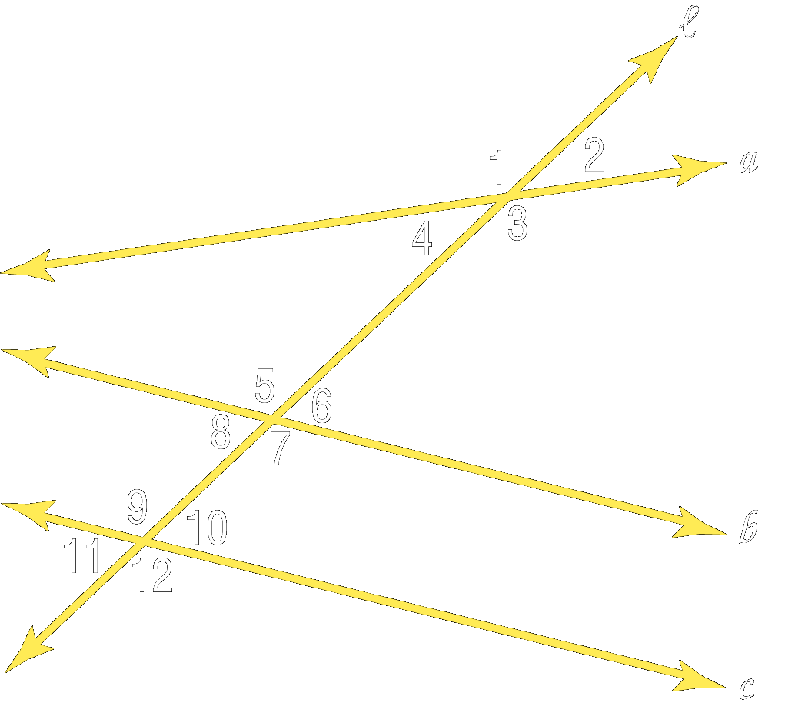
- ∠4 and ∠5

- ∠7 and ∠9

- ∠4 and ∠7

- ∠2 and ∠11

Example 3: Identify each set of angles as alternate interior, alternate exterior, corresponding, or consecutive interior angles.
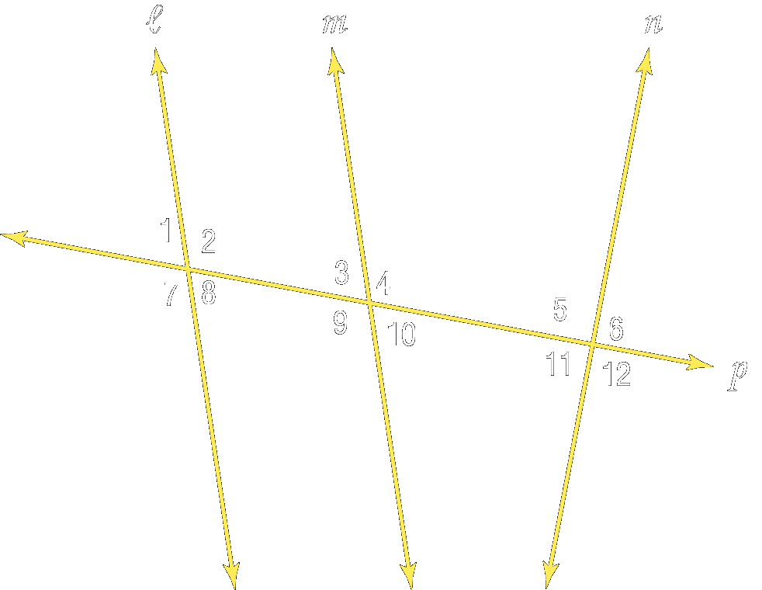
- ∠4 and ∠5

- ∠7 and ∠9

- ∠4 and ∠7

- ∠2 and ∠11

- ∠3 and ∠5

- ∠6 and ∠9

Concept Summary:
Coplanar lines that do not intersect are called parallel
When two lines are cut by a transversal, there are many angle relationships
Identify angles formed by transversals according to above table

Reading Assignment: Section 3.2

Homework: pg 129 – 131: 11-17, 70-75
Section 3-2: Angles and Parallel Lines

SOL: G.3 The student will solve practical problems involving complementary, supplementary, and congruent angles that include vertical angles, angles formed when parallel lines are cut by a transversal, and angles in polygons.

Objectives:
Use the properties of parallel lines to determine congruent angles
Use algebra to find angle measures

Vocabulary: No new vocabulary words or symbols

Key Concepts:

Example 1: In the figure x || y and m∠11 = 51°. Find m∠16

Find m∠10

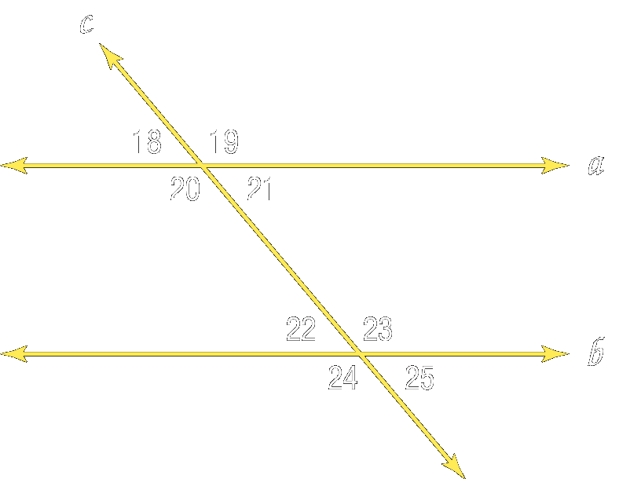
Example 2: In the figure, a || b and m∠18 = 42°.
Find m∠19 and m ∠25

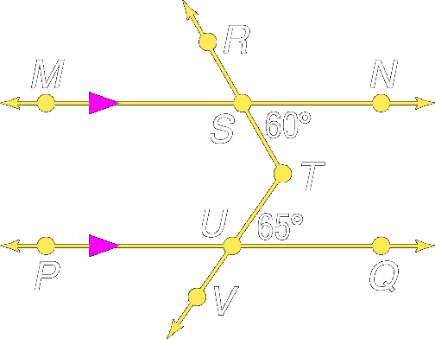
Example 3: What is the measure of ∠RTV?

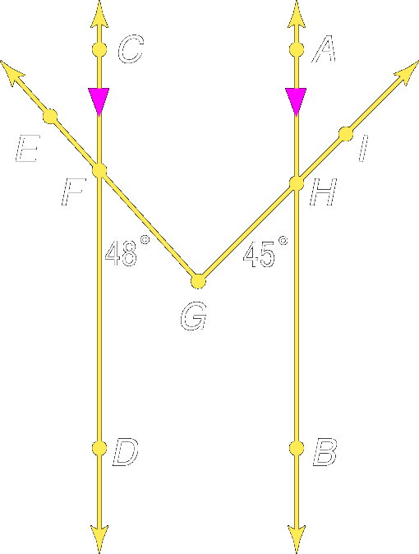
Example 4: What is the measure of ∠IGE?

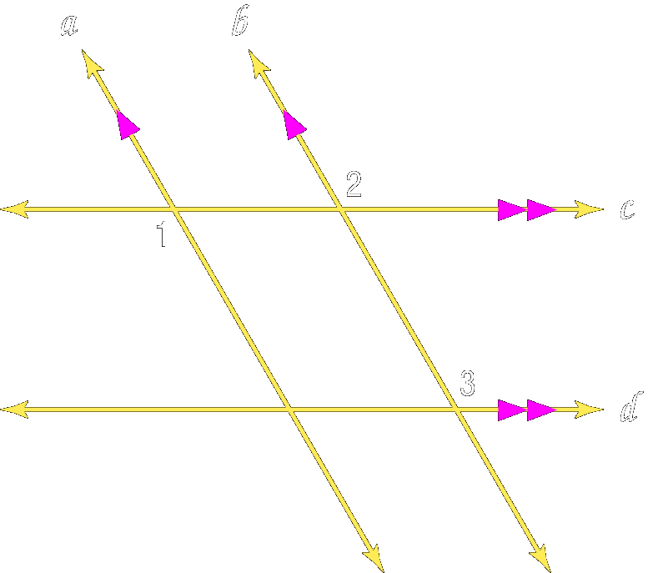
Example 5: If m∠1 = 9x + 6, m∠2 = 2(5x – 3), and m∠3 = 5y + 14,
find x and y.

Concept Summary:
Pairs of congruent angles formed by parallel lines and a transversal are corresponding angles, alternate interior angles and alternate exterior angles
Pairs of consecutive interior angles are supplementary

Reading Assignment: Section 3.3

Homework: Day 1: pg 136 – 137: 1, 5-11, 14-19
Day 2: pg 136 – 137: 20-25, 26, 27, 29, 31, 39
Section 3-3: Slopes of Lines

SOL: G.2 The student will use pictorial representations, including computer software, constructions, and coordinate methods, to solve problems involving symmetry and transformation. This will include
a) investigating and using formulas for finding distance, midpoint, and slope;

Objectives:
Find slopes of lines
Use slopes to identify parallel and perpendicular lines

Vocabulary:
Slope – Vertical rise / horizontal run (or Δy/Δx)
A horizontal line has a slope of zero (no change in y)
A vertical line has an undefined slope (no change in x)
Rate of change – describes how a quantity changes over time

Key Concepts:
Slope, symbol m: m = y₂ – y₁
x₂ – x₁

Postulates:

  - Two non-vertical lines have the same slope if, and only if, they are parallel.
  - Two non-vertical lines are perpendicular if, and only if, the product of their slopes is -1.

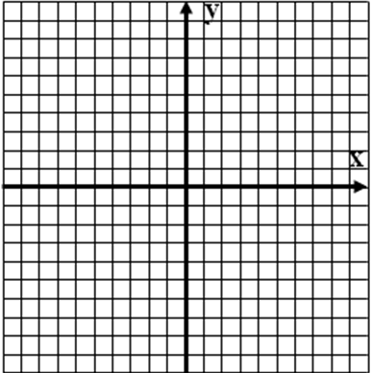
Example 1: Find the slope of the line passing through
(-3,7) and (-1,-1).

Example 2: Find the slope of the line passing through
(0,4) and (0,-3).

Example 3: Find the slope of the line passing through
(-2,-5) and (6,2).

Example 4: Find the slope of the line passing through
(-2,-1) and (6,-1).

Example 5: Determine whether FG and HJ are parallel, perpendicular, or neither.
F(4,2), G(6,-3), H(-1,5), J(-3,10)

Example 6: Determine whether AB and CD are parallel, perpendicular, or neither.
A(-2,-1), B(4,5), C(6,1), D(9,-2)

Example 7: Determine whether AB and CD are parallel, perpendicular, or neither.
A(7,-3), B(1,-2), C(4,0), D(-3,1)

Concept Summary:
The slope of the line is the ratio of its vertical rise to its horizontal run
Parallel lines have the same slope
Perpendicular lines have slopes whose product is -1 (also known as negative inverses)

Reading Assignment: Section 3.4

Homework: pg 142-143: 15, 16, 19, 20, 25, 27, 29, 30
Section 3-4: Equations of Lines

SOL: None

Objectives:
Write an equation of a line given information about its graph
Solve problems by writing equations

Vocabulary:

Key Concepts: None

Example 1: Write an equation in slope-intercept form of the line with slope of 6 and y-intercept of –3.

Example 2: Write an equation in point-slope form of the line whose slope is -3/5 that contains (–10, 8).

Example 3: Write an equation in point-slope form of the line whose slope is ⅓ that contains (6, –3).

Example 4: Write an equation in slope-intercept form for a line containing (4, 9) and (–2, 0).

Example 5: Write an equation in slope-intercept form for a line containing (3, 2) and (6, 8).

Example 6: Write an equation in slope-intercept form for a line containing (1, 7) that is perpendicular to
the line y= -½x + 1

Example 7: A car rental company charges $25 per day plus a $100 deposit.

a. Write an equation to represent the total cost C for d days of use.

b. Compare this rental cost to a company which charges a $50 deposit but $35 per day for use. If a person expects to rent a car for 9 days, which company offers the better rate?

Concept Summary:
An equation of a line can be written if you are given:
The slope and the y intercept, or
The slope and the coordinates of a point on the line, or
The coordinates of two points on the line

Reading Assignment: Section 3.5

Homework: pg 148-149: 15-19, 21, 35, 37, 47
Section 3-5: Proving Lines Parallel

SOL: G.4 The student will use the relationships between angles formed by two lines cut by a transversal to determine if two lines are parallel and verify, using algebraic and coordinate methods as well as deductive proofs.

Objectives:
Recognize angle conditions that occur with parallel lines
Prove that two lines are parallel based on given angle relationships

Vocabulary: No new vocabulary words or symbols

Key Concepts:

Theorem 3.8: In a plane, if two lines are perpendicular to the same line, then they are parallel
If l ⊥ n and l ⊥ m, then m || n.

Example 1: Determine which lines, if any, are parallel.

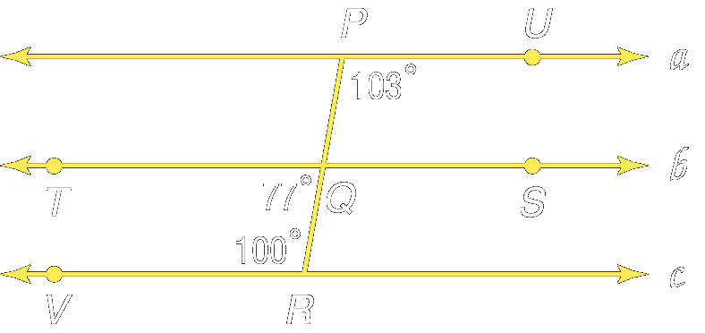

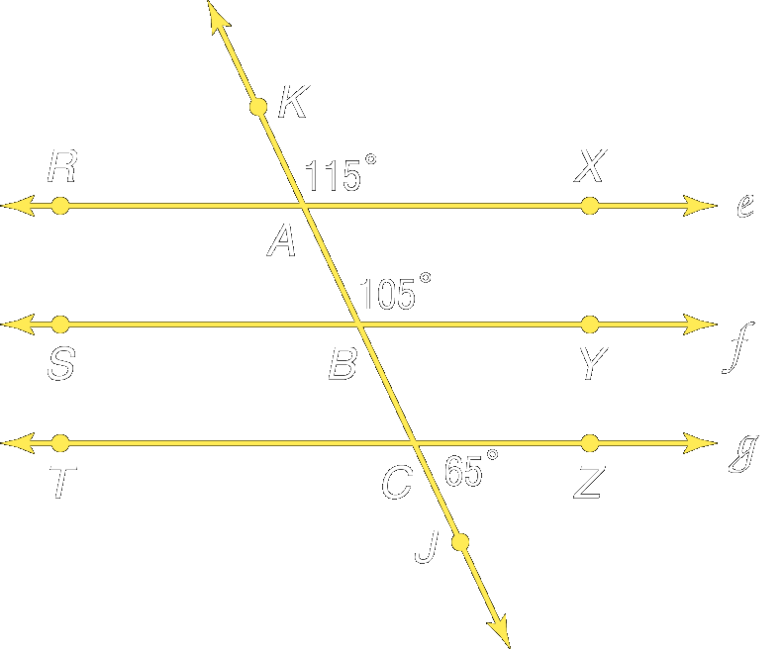
Example 2: Determine which lines, if any, are parallel.

Example 3: Find x and m∠ZYN so that PQ || MN
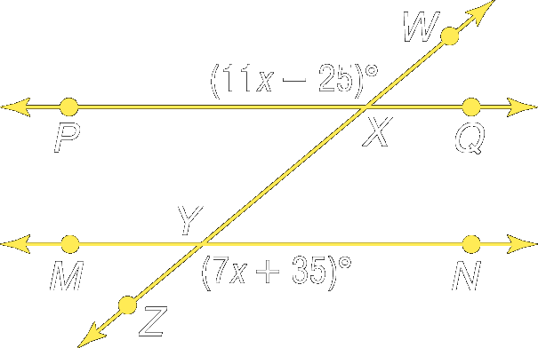

Example 4: Find x and m∠GBA so that GH || RS

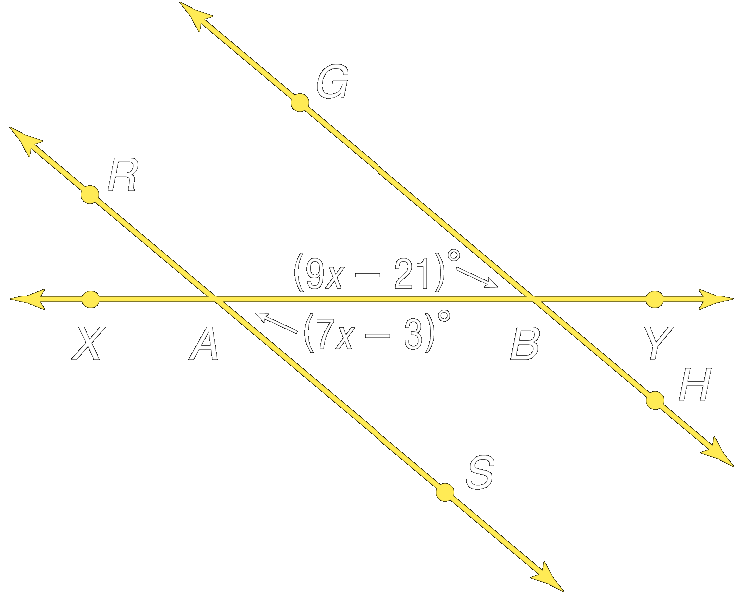

Concept Summary:
When lines are cut by a transversal, certain angle relationships produce parallel lines
- Congruent corresponding angles
- Congruent alternate interior angles
- Congruent alternate exterior angles
- Supplementary consecutive interior angles

Reading Assignment: Section 3.6

Homework: pg 154-155: 4, 7, 13-16, 27, 29, 31
Section 3-6: Perpendiculars and Distance

SOL: None.

Objectives:
Find the distance between a point and a line
Find the distance between parallel lines

Vocabulary:
Equidistant – has the same distance (parallel lines are equidistant everywhere)
Locus – the set of all points that satisfy a given condition (parallel lines can be described as the locus of points in a plane equidistant from a given line)

Key Concepts:

The (shortest) distance between a line and a point not on the line is the length of the segment perpendicular to the line from the point.

The distance between two parallel lines is the distance between one of the lines and any point on the other line.

Theorem 3.9: In a plane, if two lines are equidistant from a third line, then the two lines are parallel to each other.

Concept Summary:
Distance between a point and a line is measured by the perpendicular segment from the point to the line.

Reading Assignment: Reread Chapter 3

Homework: pg 163: 21, 25, 27

Chapter 3 review: Practice Test on page 171
Chapter 2 Review:
1. Make a conjecture about the next item in the sequence: 5, 20, 80, 320.

2. Write the contrapositive for this statement:
If you live in Boston, then you live in Massachusetts.

3. Use the Law of Detachment or the Law of Syllogism to determine whether a valid conclusion can be reached from the following set of statements: If two angles form a linear pair and are congruent, they are both right angles. ∠A and ∠B are both right angles.

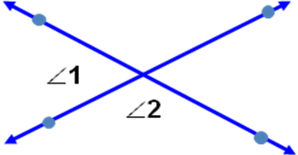
4. Name the property that justifies the statement.
If m∠1 + m∠2 = 75° and m∠2 = m∠3, then m∠1 + m∠3 = 75°.

5. Find m∠1 and m∠2 if m∠1 = 8x + 18, and m∠2 = 16x – 6.

6. The measures of two complementary angles are in the ratio 7:8. What is the measure of the larger angle?
a. 42 b. 48 c. 84 d. 96

Section 3-1:
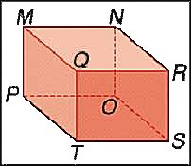
Refer to the figure.

1. Name all planes parallel to MNR.

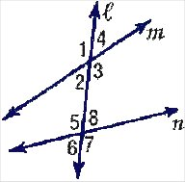
2. Name all segments skew to MP.

Give the special name for each angle pair in the figure.
3. ∠1 and ∠5
4. ∠3 and ∠8
5. ∠4 and ∠6
6. How many pairs of alternate interior angles are there in the figure above?
a. 1 b. 2 c. 3 d. 4

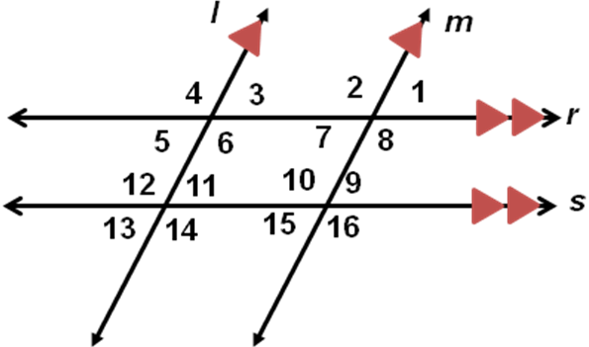
Section 3-2:
In the figure, m∠4 = 146°. Find the measure of the following angles.

- ∠2
- ∠7
- ∠10
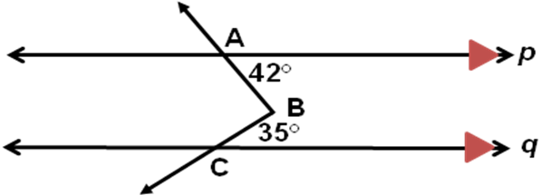
4. ∠11
5. Find m∠11 + m∠6

6. In the figure to the right what is the measure of ∠ABC?
a. 77 b. 84 c. 89 d. 91

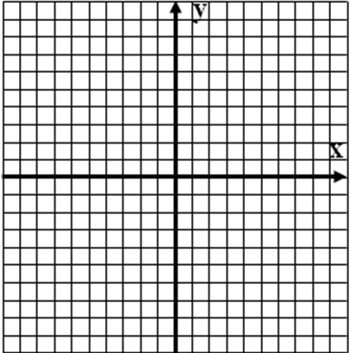
Section 3-3:
Find the slope of each line for M(–3, 4) and N(5, –8).

1. MN
2. a line perpendicular to MN
3. a line parallel to MN
Graph the line that satisfies each condition.
4. slope = 4 and 5. slope = 0 and
contains (1, 2) contains (–3, –4)

6. Use slope to find a relationship between CD and EF for C(4, 5), D(–1, 15), E(–4, –6), F(0, –8).

Section 3-4:
Write an equation in point-slope form for each line.
1. line with slope ¾ containing (5, –2)
2. line parallel to the line 3x – y = 6 that contains (–2, 7)
Write an equation in slope-intercept form for each line.
3. line with slope –3 containing (0, 2.5)
4. line with slope –1/2 containing (4, –6)
5. line through (1, 5) and (3, 11)
6. Which of the following describes the line y = –2/3x + 6?

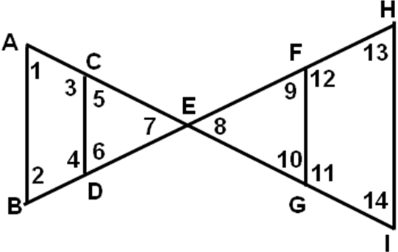
Section 3-5:
Given the following information, determine which segments, if any, are parallel. State the postulate or theorem that justifies your answer.
1. ∠9 ≅ ∠13
2. ∠2 ≅ ∠5
3. m∠2 + m∠4 = 180°
4. ∠5 ≅ ∠14
5. Refer to the figure above. Find x so that AB || CD if
m∠1 = 4x + 6 and m∠14 = 7x – 27.
6. If ℓ, m and p are coplanar lines such that ℓ ⊥ p and p ⊥ m, which statement is valid?

